Azure Cloud:

* Different Types of services in Cloud

1. IAAS : you get raw hardware, install your choice of OS. You have control on this service but overhead of managing the Infra team.  I.e. Amazon EC2/Azure VM
2. PASS : You will get an OS installed by a Cloud provider and install your apps on it. I.e. Mobile Apps or Web Apps
3. SAAS : You will use the software with purchasing it or just rent it out for use. i.e. when launching a VM on Azure, we are not buying the OS, we are basically renting it for the time you will be running that instance.

* Cloud Computing :- It is use of servers on the internet for “storage”, “manage” and “process” data. Instead of using our own resources, we are using someone else and paying an amount for the time we use.

* Different Type of Cloud deployment models:-

1. Public : The infrastructure is owned by your cloud provider and the server that you are using could be a multi-tenant system.
2. Private : The infrastructure own by you or your cloud provider and provided exclusively. (Its dedicated server)
3. Hybrid : Combination of Public and Private cloud where you host sensitive data on on-prem/Private cloud and public facing websites on public cloud.

* Resource Manager: It manages infrastructure which includes a number of services. It is useful to deploy, manage and delete all the resources together using a simple JSON script.

* Roles and why do we use them

1. Web Role : A web role is basically used to deploy a website, using languages supported by the IIS platform
2. Worker Role : A worker role is more like an help to the Web role, it used to execute background processes unlike the Web Role which is used to deploy the website.
3. VM Role : The VM role is used by a user to schedule tasks and other windows services. This role can be used to customize the machines on which the web and worker role is running.

* Availability Set: :Logical grouping of VM that allows Azure to understand how your application to build to provide redundancy and availability.

* Network Security Group :- NSG contains list of Access Control Lists(ACL) that allow or deny network traffic to subnet, NICs or both
* Break-fix issue :- Technical problems are called break-fix issue, it is an industry term which refers to “work involved in supporting a technology when it fails in the normal course of its function, which requires intervention by a support organization to be restored to working order”
* What is horizontal/vertical scaling
* Blob Storage and It’s features

Azure Blob storage is a service used for storing large amounts of unstructured object data, such as text/binary data. We can use Blob storage to expose data publicly to the world, or to store application data privately.   
Uses case scenario of Blob storage include:

* Serving images or documents directly to a browser
* Storing files for distributed access
* Streaming video and audio
* Storing data for backup and restore, disaster recovery, and archiving
* Storing data for analysis by an on-premises or Azure-hosted service
* Azure Datalake (Gen1 & Gen 2)

[Azure Data Lake Storage Gen1](https://docs.microsoft.com/en-us/azure/data-lake-store/) (formerly Azure Data Lake Store, also known as ADLS) is an enterprise-wide hyper-scale repository for big data analytic workloads. Azure Data Lake Storage Gen1 enables you to capture data of any size, type, and ingestion speed in a single place for operational and exploratory analytics. Azure Data Lake Storage Gen1 is specifically designed to enable analytics on the stored data and is tuned for performance for data analytics scenarios.

Azure Data Lake Storage Gen2 (also known as ADLS Gen2) is a next-generation data lake solution for big data analytics**. Azure Data Lake Storage Gen2 builds Azure Data Lake Storage Gen1 capabilities—file system semantics, file-level security, and scale—into Azure Blob storage, with its low-cost tiered storage, high availability, and disaster recovery features.** The Azure Blob File System (ABFS) driver provides the interface to ADLS Gen2 storage. The ABFS driver, included in the Databricks Runtime, supports standard file system semantics on Azure Blob storage.

* Azure Functions

Azure Functions is a serverless solution that allows you to write less code, maintain less infrastructure, and save on costs. Instead of worrying about deploying and maintaining servers, the cloud infrastructure provides all the up-to-date resources needed to keep your applications running.

Azure Functions allows you to implement your system's logic into readily available blocks of code. These code blocks are called "functions". Different functions can run anytime you need to respond to critical events.

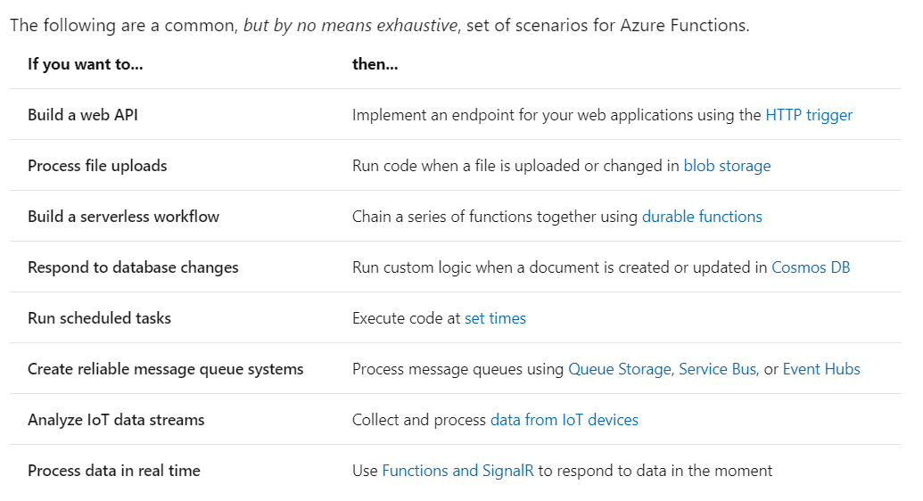

* Azure Storage Replication

Azure Storage always stores multiple copies of your data so that **it is protected from planned and unplanned events, including transient hardware failures, network or power outages, and massive natural disasters**. Redundancy ensures that your storage account meets its availability and durability targets even in the face of failures.  
Data in an Azure Storage account is always replicated three times in the primary region. Azure Storage offers two options for how your data is replicated in the primary region: Locally redundant storage (LRS) copies your data synchronously three times within a single physical location in the primary region.

**Locally Redundant Storage**: Its copy data synchronously three times within a single physical location in the primary region. LRS is the least expensive replication option, but is not recommended for applications requiring high availability.

**Zone Redundant Storage**: It replicate Azure Storage data synchronously across three Azure availability zones in the primary region. Each availability zone is a separate physical location with independent power, cooling, and networking. ZRS offers durability for Azure Storage data objects of at least 99.9999999999%

Redundancy in Secondary Region:

For applications requiring high availability, you can choose to additionally copy the data in your storage account to a secondary region that is hundreds of miles away from the primary region. If your storage account is copied to a secondary region, then your data is durable even in the case of a complete regional outage or a disaster in which the primary region isn't recoverable.